**Decision Tree Classifier :-**

**Predictor Variable and Response Variable :-**

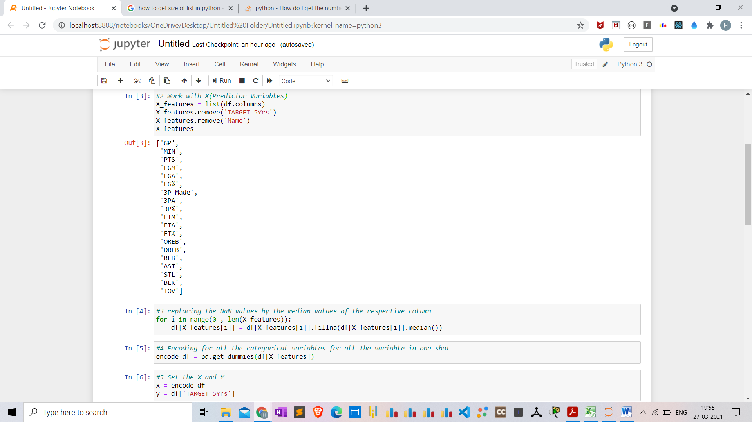

**Minimum 10 records :-**

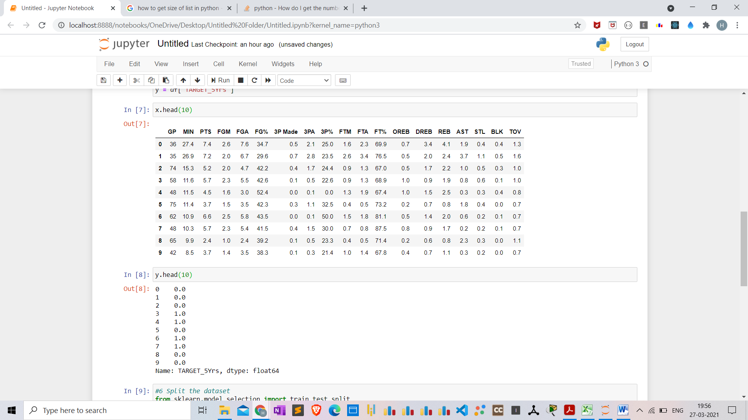

**Train the Model :-**

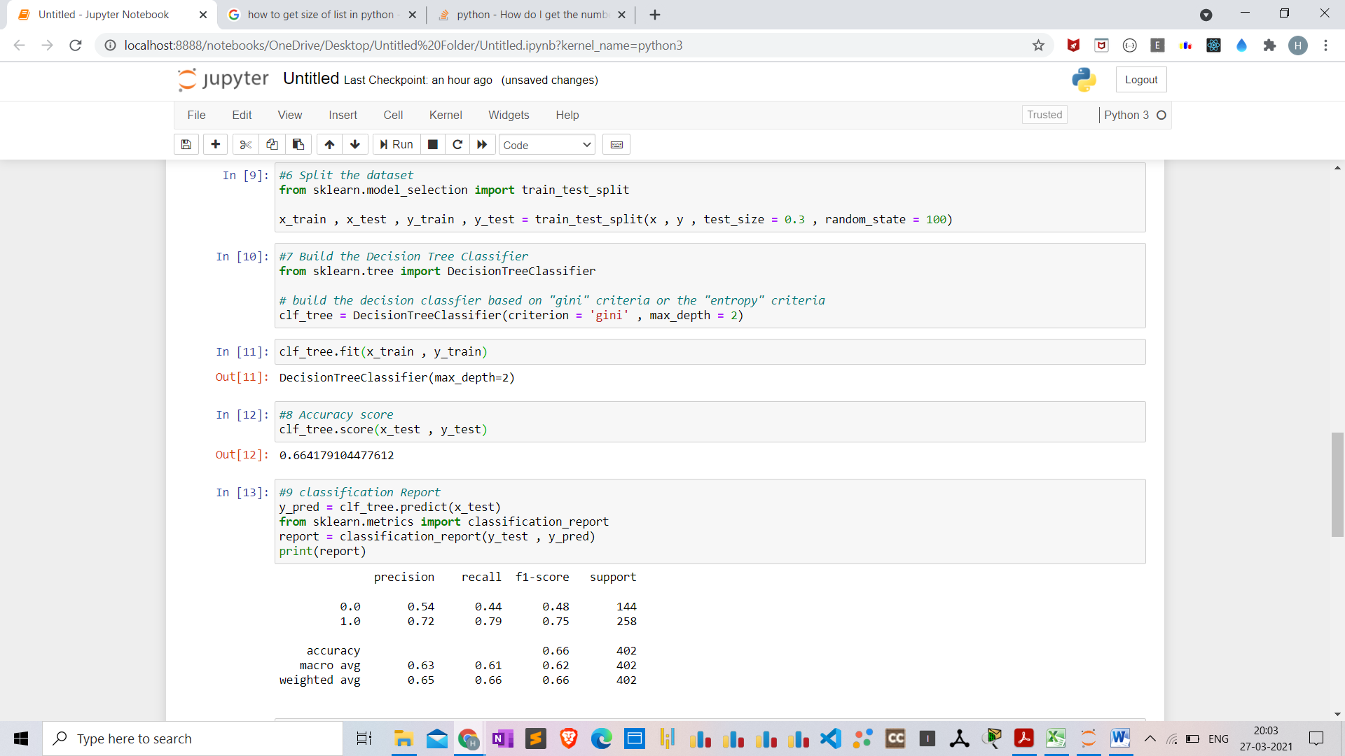

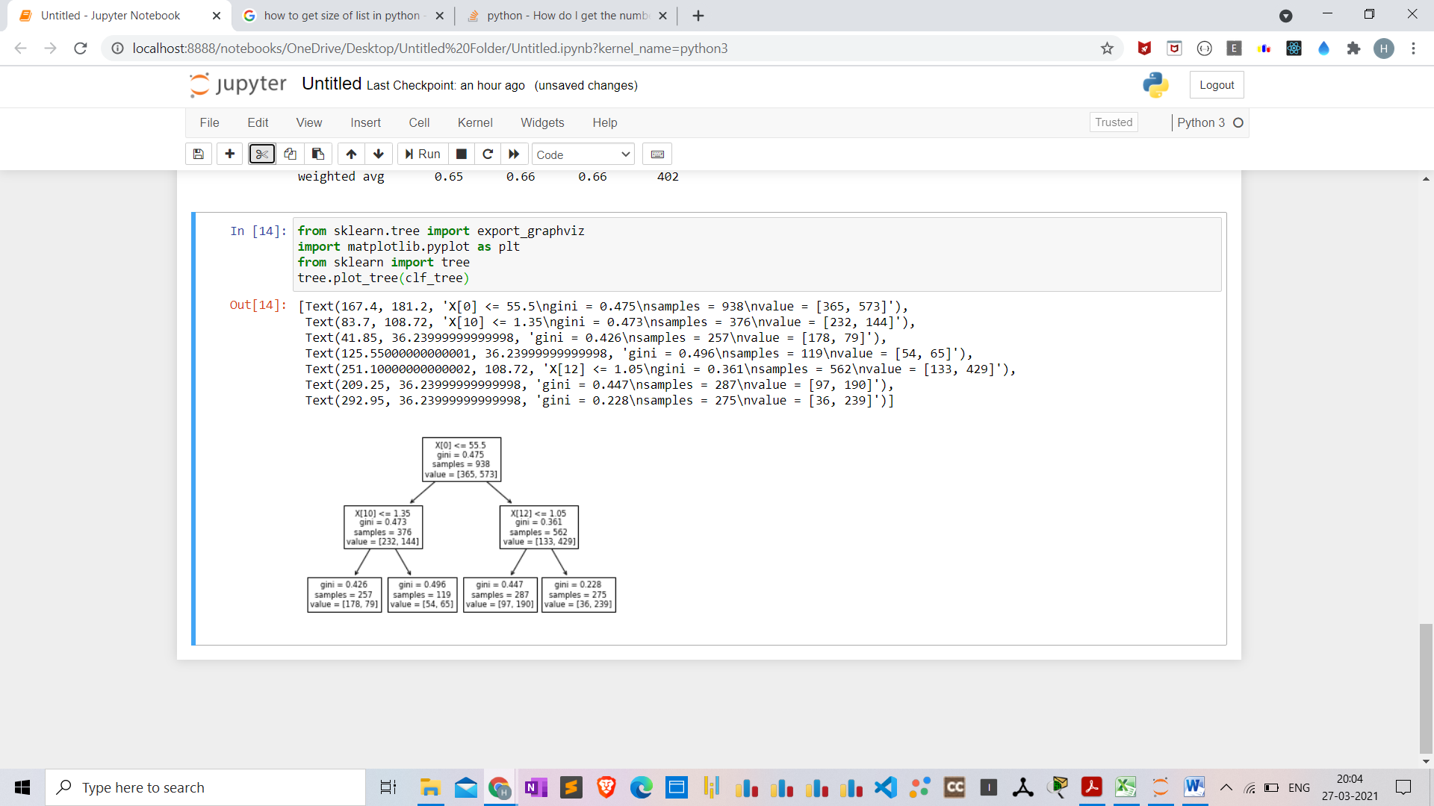

**Accuracy Score Metric :-**

1. **Classification report**

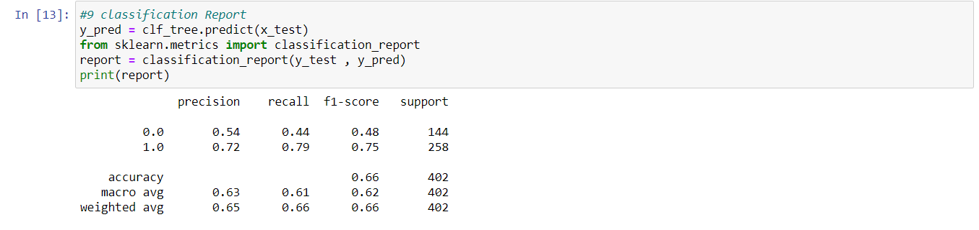

**Data Description :-**

Based on NBA rookie stats, we are predicting which players have 5 year or more career longevity.

**DataSet link :-**

1. <https://data.world/ssaudz/ml-classification-predicting-5-year-career-longevity-for-nb/workspace>
2. <https://data.world/ssaudz/ml-classification-predicting-5-year-career-longevity-for-nb>